Final Project for SW Engineering Class CSC 648-848 Fall 2023

weLearn - A Comprehensive SFSU Tutoring Service

**Team 04**

**WeLearn**

Akshat Sohal - Team Lead (email: asohal@mail.sfsu.edu) Zuriel Respicio - Frontend Lead (email: zrespicio@mail.sfsu.edu)

Charter Lin - Backend Lead Aakanksha Devarapally - GitHub Master

Andy Byeon Jorge Perez

<http://54.219.143.67/>

14/11/2023

**Milestone 5**

# Product summary

**Product name:** weLearn

**Product description:** Let me introduce weLearn, our web based tutoring app for San Francisco State University (SFSU) students. We're different from other tutoring services because we connect SFSU students who need help with those who've done really well in the same classes. This helps students do better in their courses and creates a supportive community at SFSU. What makes us special is our focus on helping students at our university succeed. Our app lets you get help in tough classes and gives top students a chance to become tutors. Our team has six hardworking members who work together smoothly. With leaders for the tech stuff and helpers, we stay organized with regular meetings. Come join us and discover a world of personalized help and teamwork at SFSU!

**ALL major committed functions:**

**1. Unregistered user**

○ 1.1 An unregistered user shall be able to register and become a registered user.

○ 1.2. An unregistered user shall be able to access public information on the platform without the need for authentication.

○ 1.3. Unregistered users shall have the capability to view a list of available tutors on the platform.

**● 2. Registered user**

○ 2.1. A registered user shall be able to create an account.

○ 2.2. A registered user shall have an email, username, and password

○ 2.3. A registered user shall be able to log in using email/username and password credentials.

○ 2.4. Registered user shall be able to search for SFSU classes they need help with

○ 2.5. Registered users shall have the ability to view tutor profiles.

○ 2.6. Registered users shall be able to send messages to tutors asking for appointments in person or online

○ 2.7. Registered users shall be able to apply as a tutor

○ 2.8. Registered users shall be able to post picture, resume, and optionally, a video introduction if they want to be a tutor.

○ 2.9. Registered users (if approved as tutor) shall be able to receive messages from student asking for tutoring

**● 3. Admin**

○ 3.1. Admins shall be required to review and approve or reject tutor profiles.

○ 3.2. Admin shall be required to remove inappropriate or offensive content from the platform.

○ 3.3. Admin shall be able to access tutor profiles, resumes, profile pictures, and videos.

○ 3.4. Admin shall be able to access student username, email, and profile picture.

**What is unique in our product:** What makes our product unique is that it's made specifically for SFSU students. It connects students who need help with others who did well in the same courses, creating a supportive community. Our app is easy to use, letting students schedule tutoring sessions that fit their schedules. Plus, it follows SFSU rules, making it safe and reliable. Also, it gives students a chance to become tutors themselves, making it a helpful learning tool and a way to give back to the community at the same time.

**Product URL:** [**http://54.219.143.67/**](http://54.219.143.67/)

# 

# 2. Milestone documents:

Printed M1-M4 as hard copy and put it in folder to turn in.

# 3. Product Screenshots:

**Home page:**

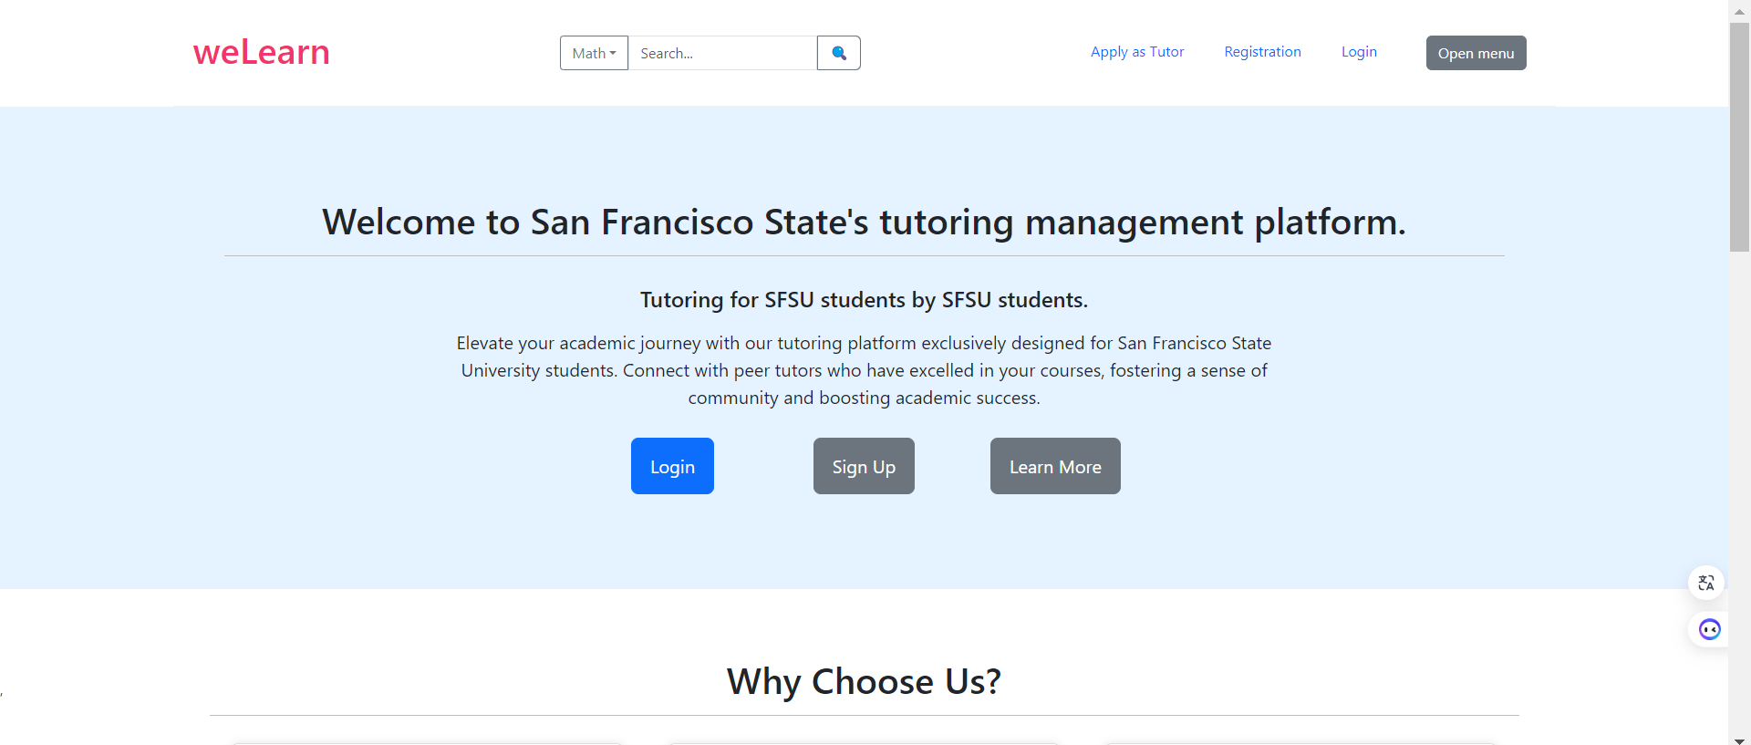

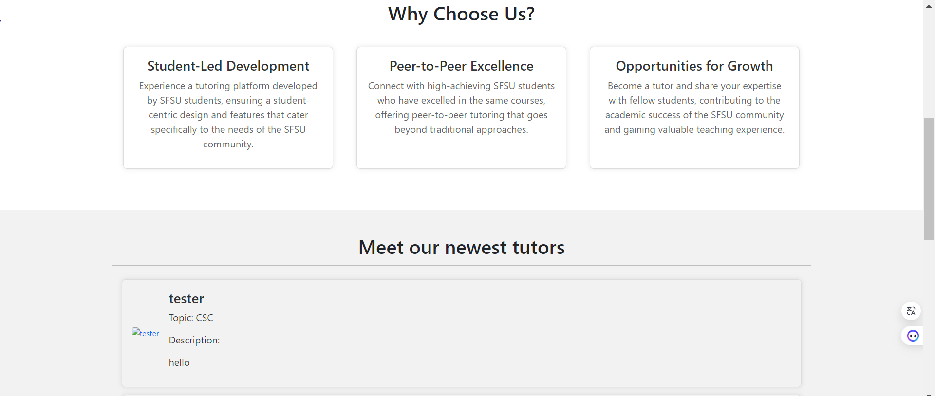

**Login / Apply as Tutor page:**

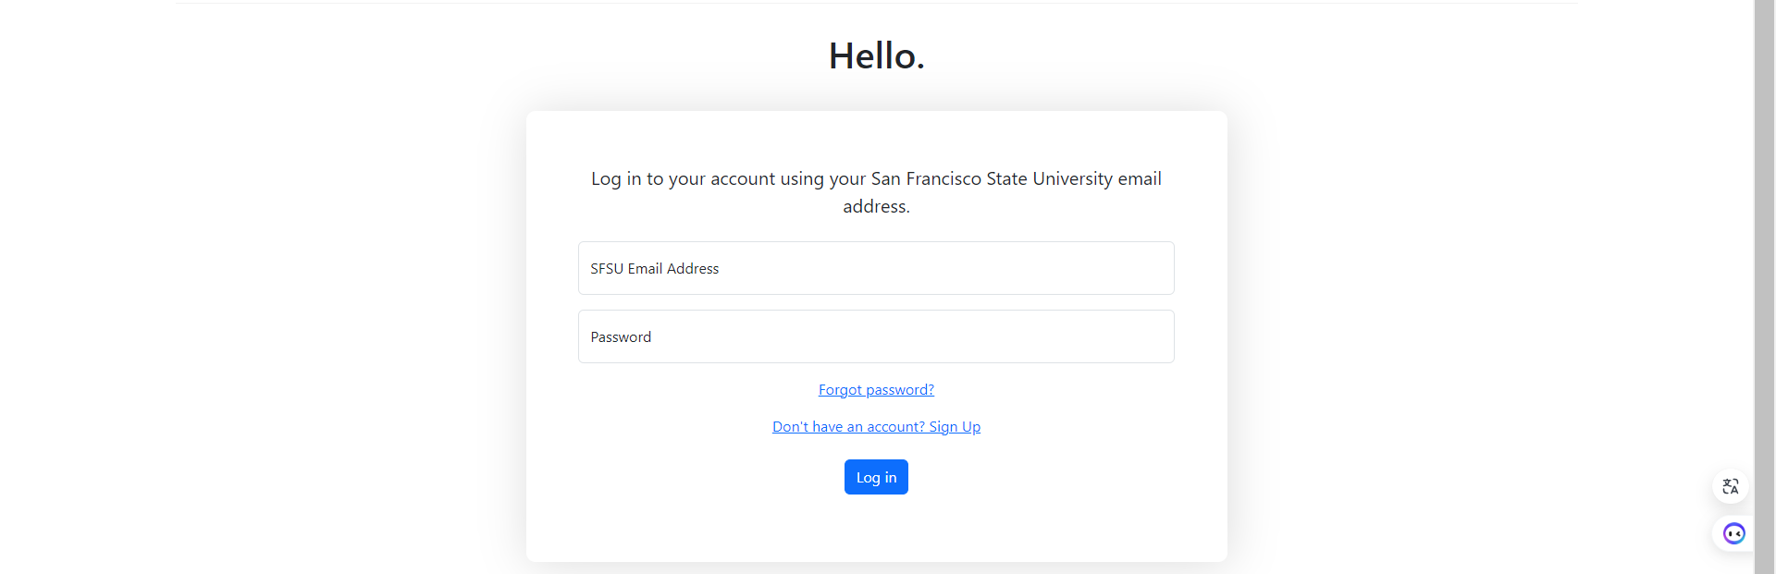

**Registration page:**

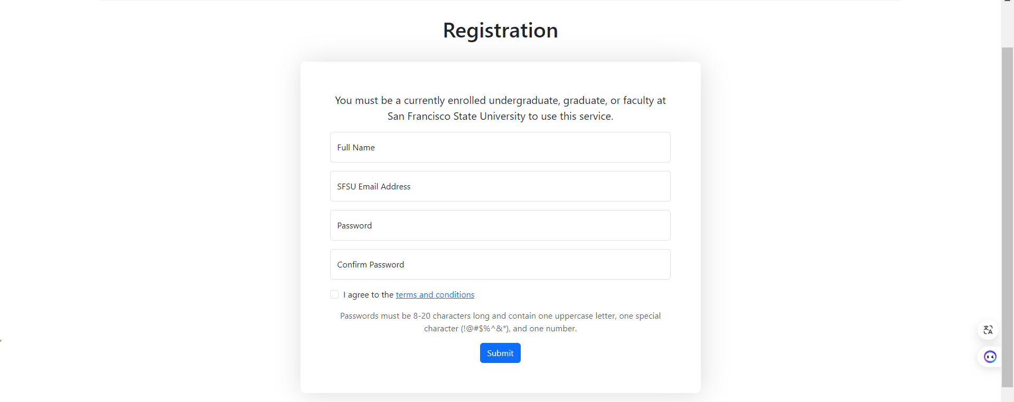

**Search page:**

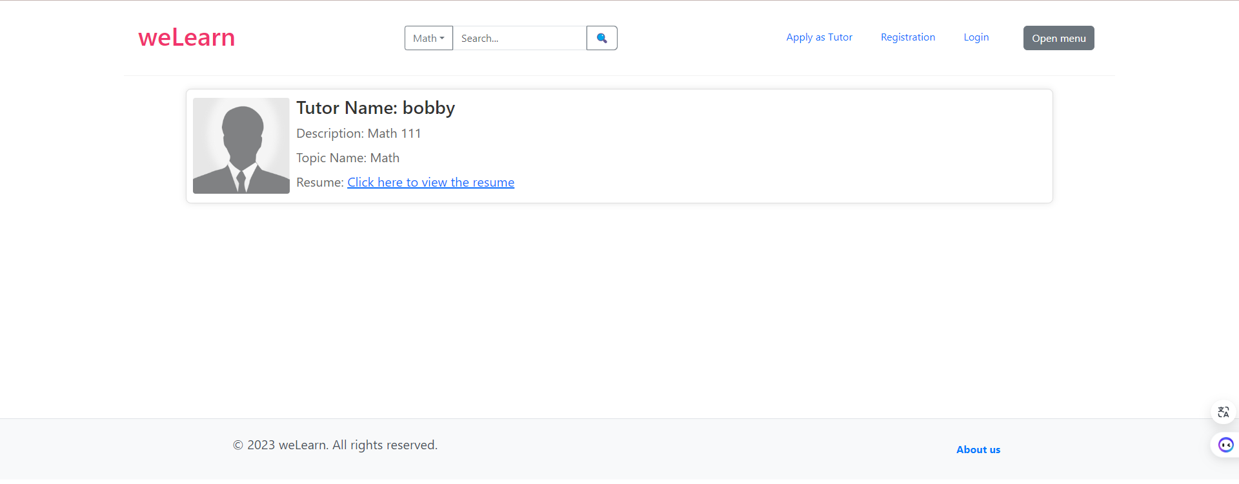

**About us page:**

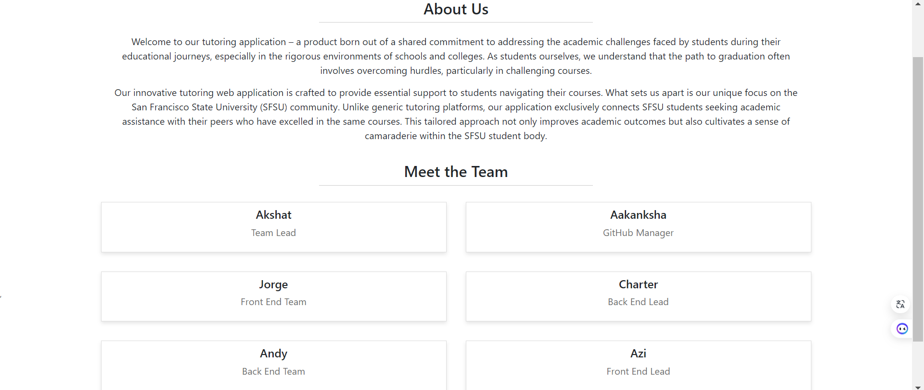

# 4. Database Organization:

(Screenshots of key DB tables (1-3 pages) Show snapshots of all important DB tables. Make it easy to read and review. OK to show screen shots of WorkBench. Ensure screen shots are easy to read.

User table:

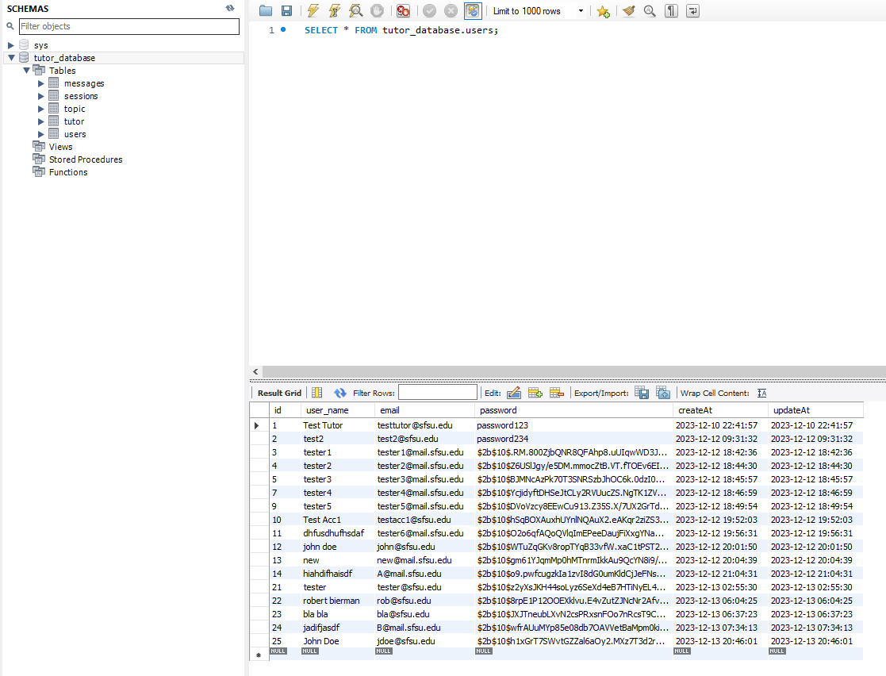

Tutor table:

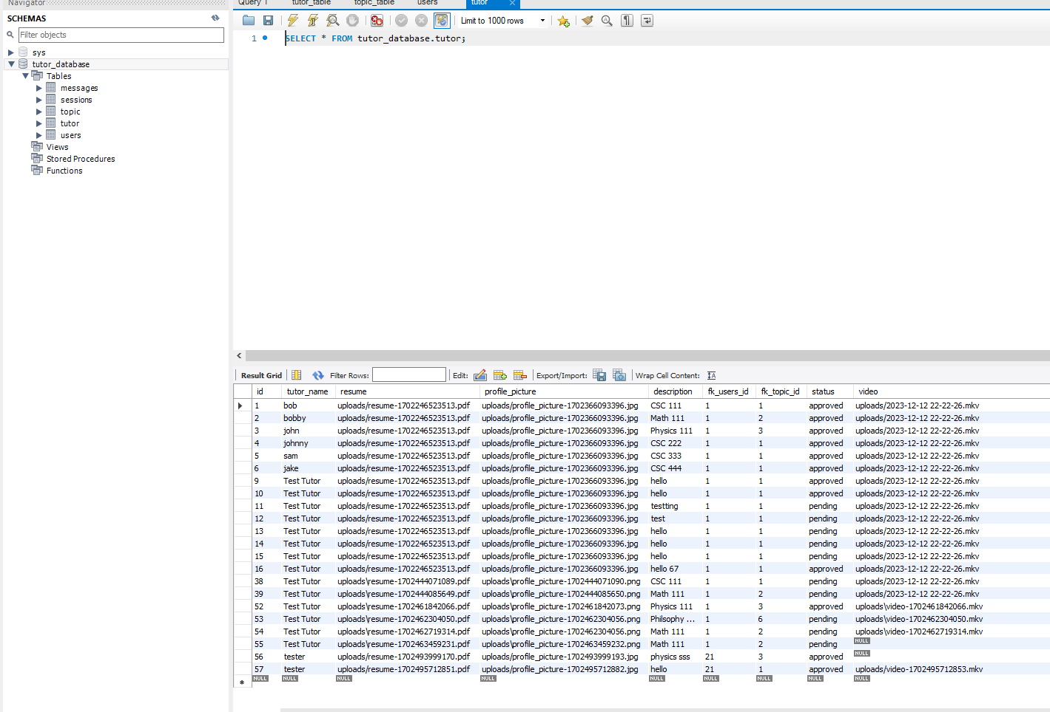

Topic table:

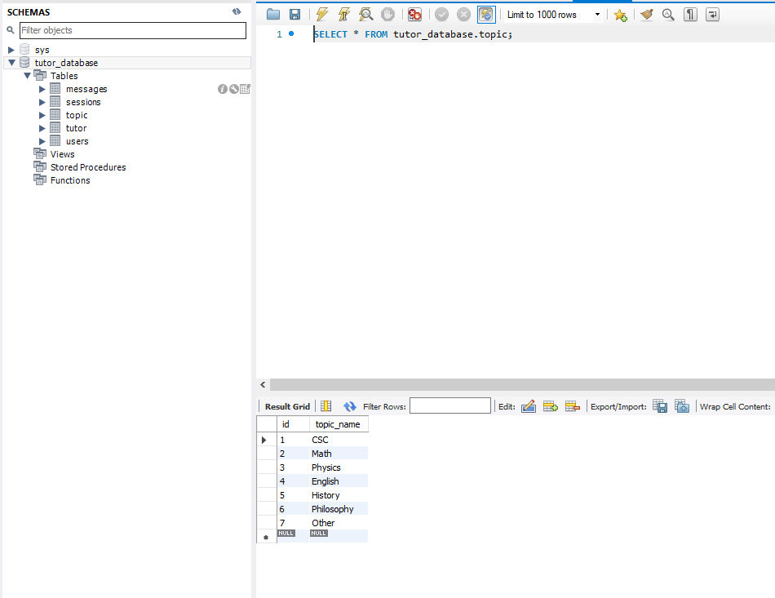

# 5. Github organization:

a) list main branches in your team github and clarify who had access to master branch; b) provide screenshot of your team github home page

Our main branches, are “main” (master branch) and “develop”. We also have miscellaneous feature branches that team members worked on. These feature branches are merged into develop for testing as a whole and working code gets moved to main/master. Main/master can only be accessed by the team lead and github master. Develop can only be accessed by the team lead, github master, and backend/frontend leads.

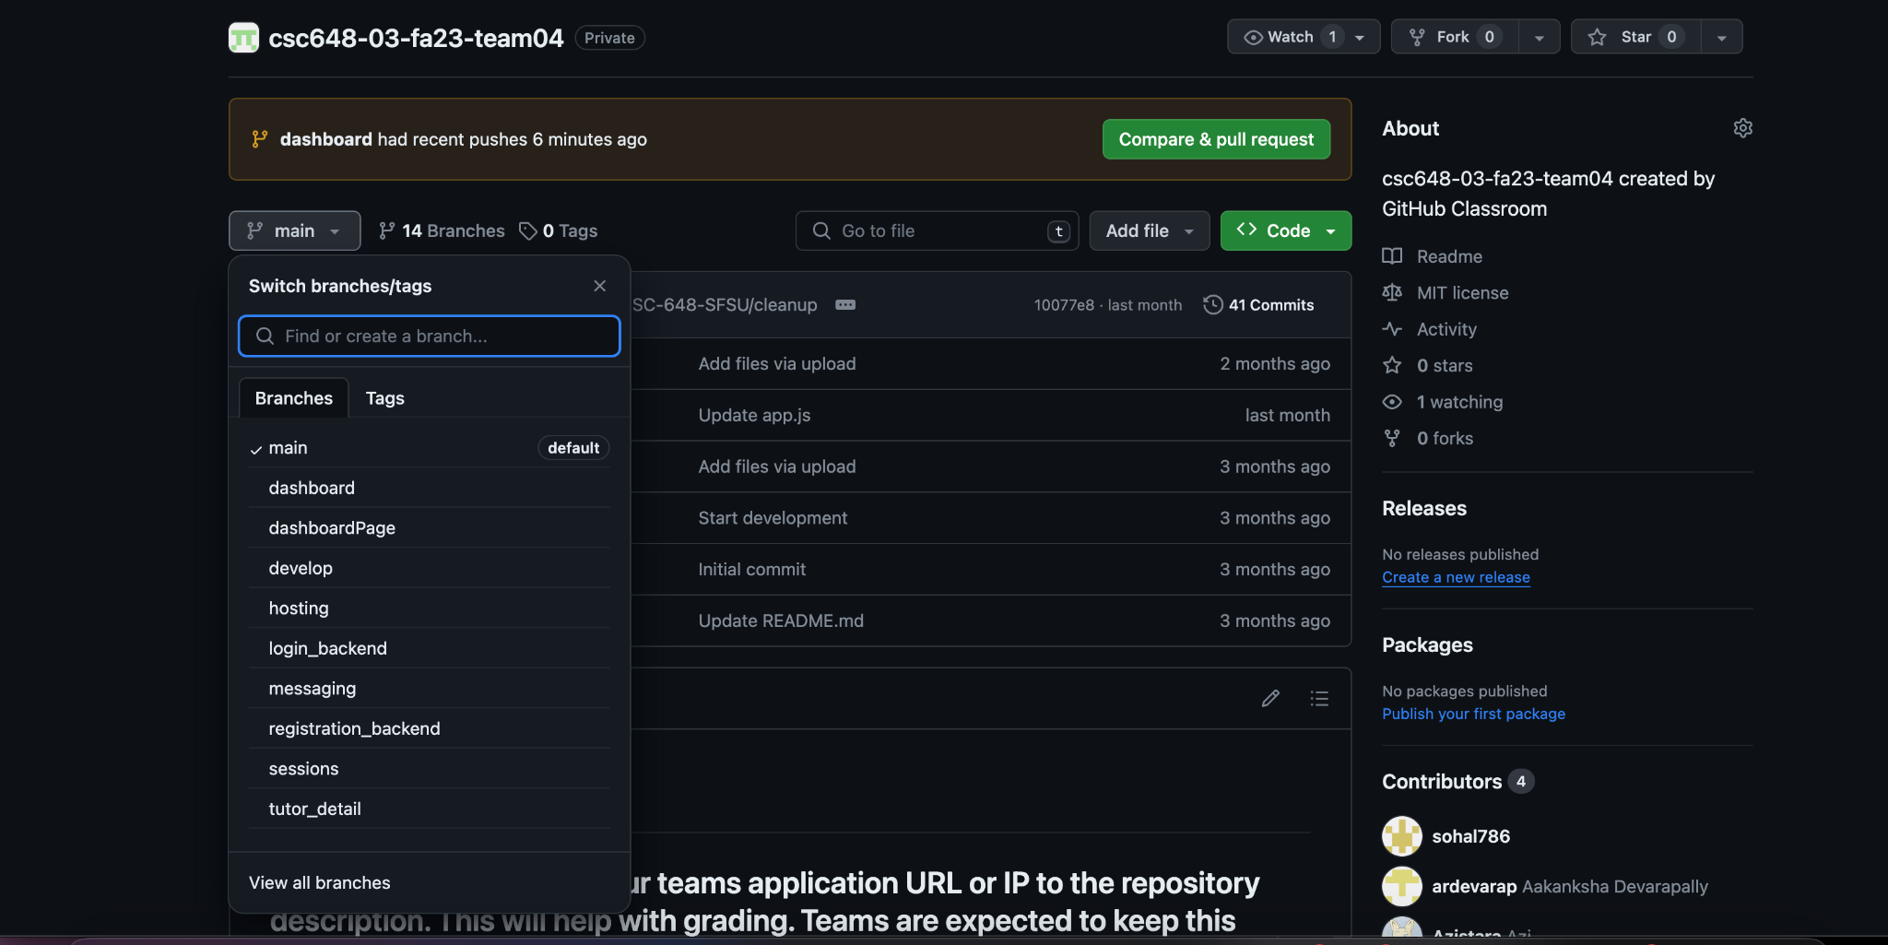

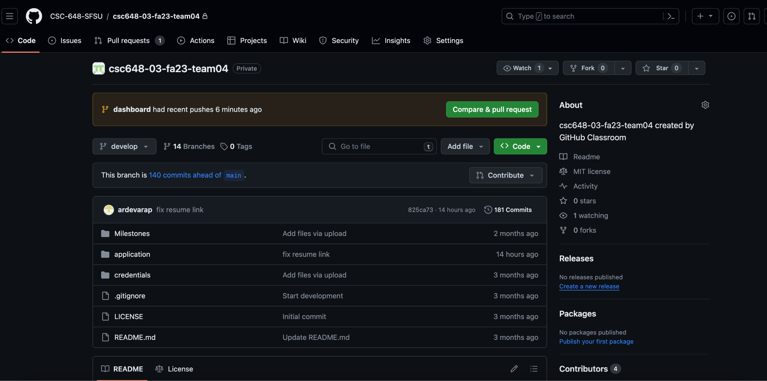

# 6. Google analytics stats plot for your WWW site:

(1 page). Ok to have stats just for a few days.

# 

7. Project Management

We started using Trello, but we gave up on using it, as we thought that it was better to use discord and excel, we made this decision to make clear which tasks were assigned to each, and discord was useful to have better communication. Despite this, we had some problems with communication and tasks assignment so maybe next time we should use Trello.  
**Example of Discord communication:**  
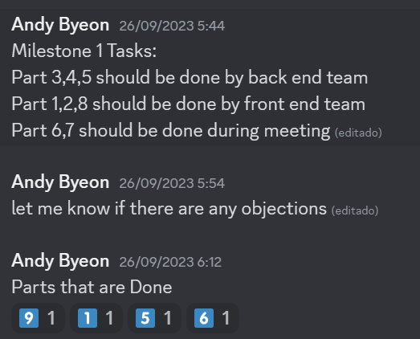

**Excel used for task assignments:**

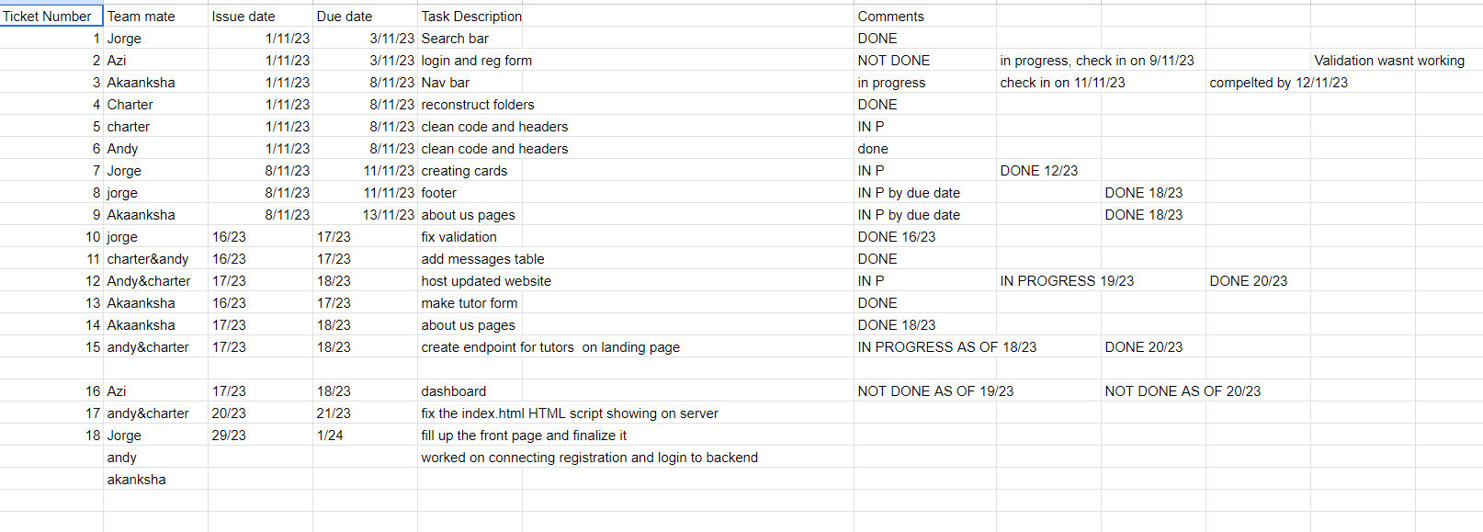

8. Team Members self assessment and contribution

Charter:

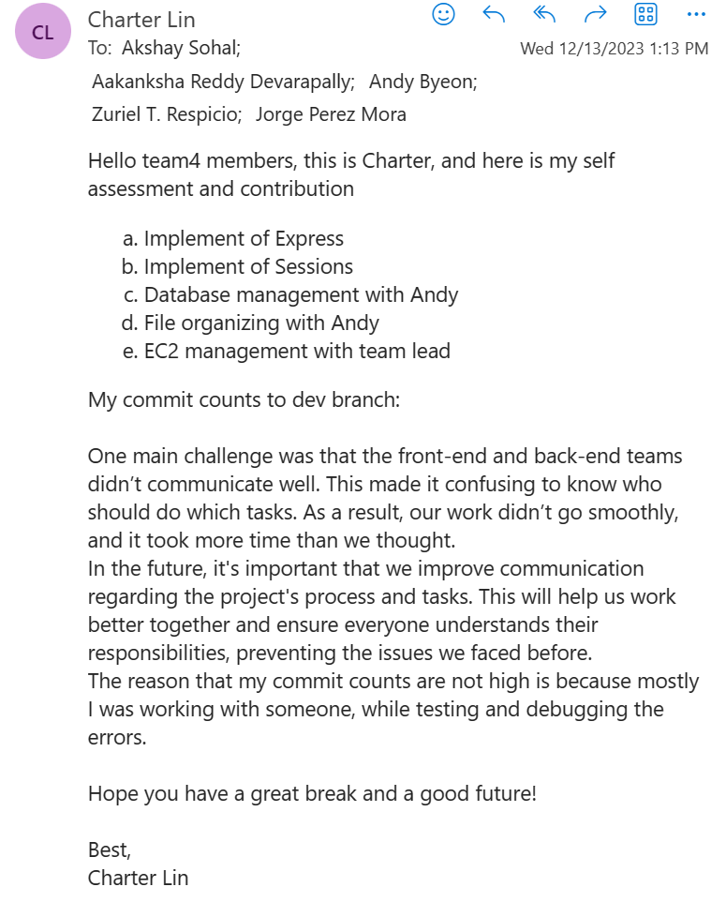

Andy:  
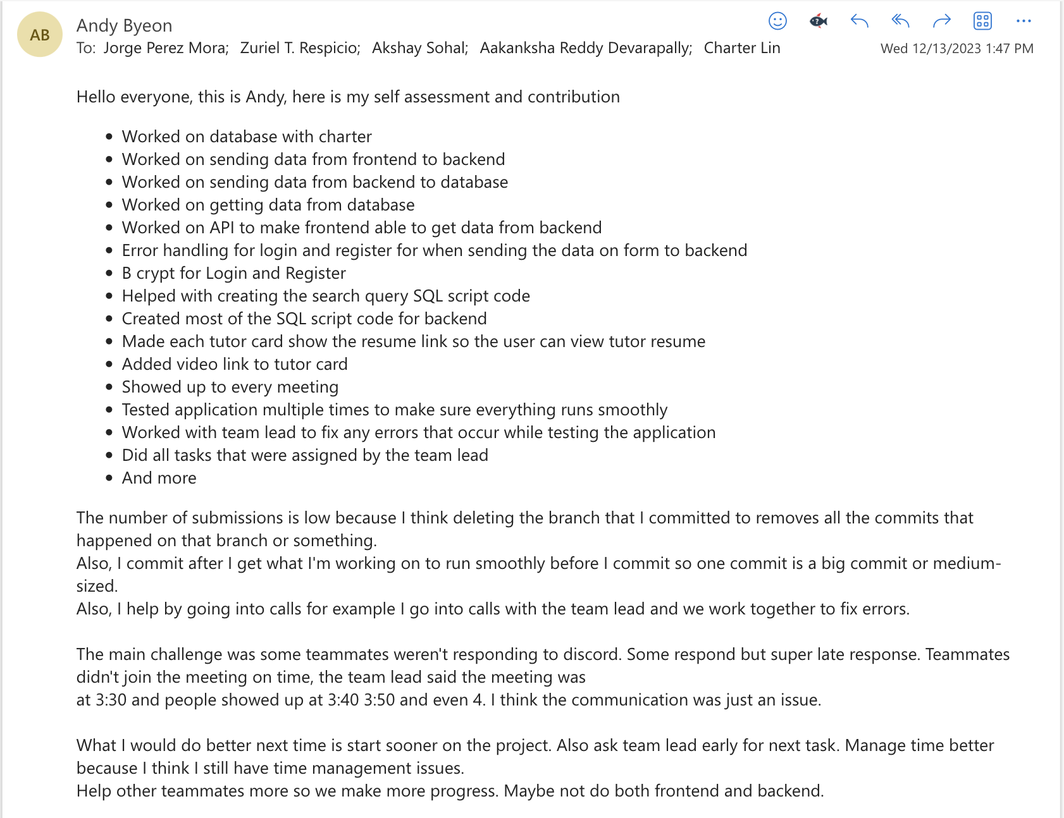

Aakanksha:  
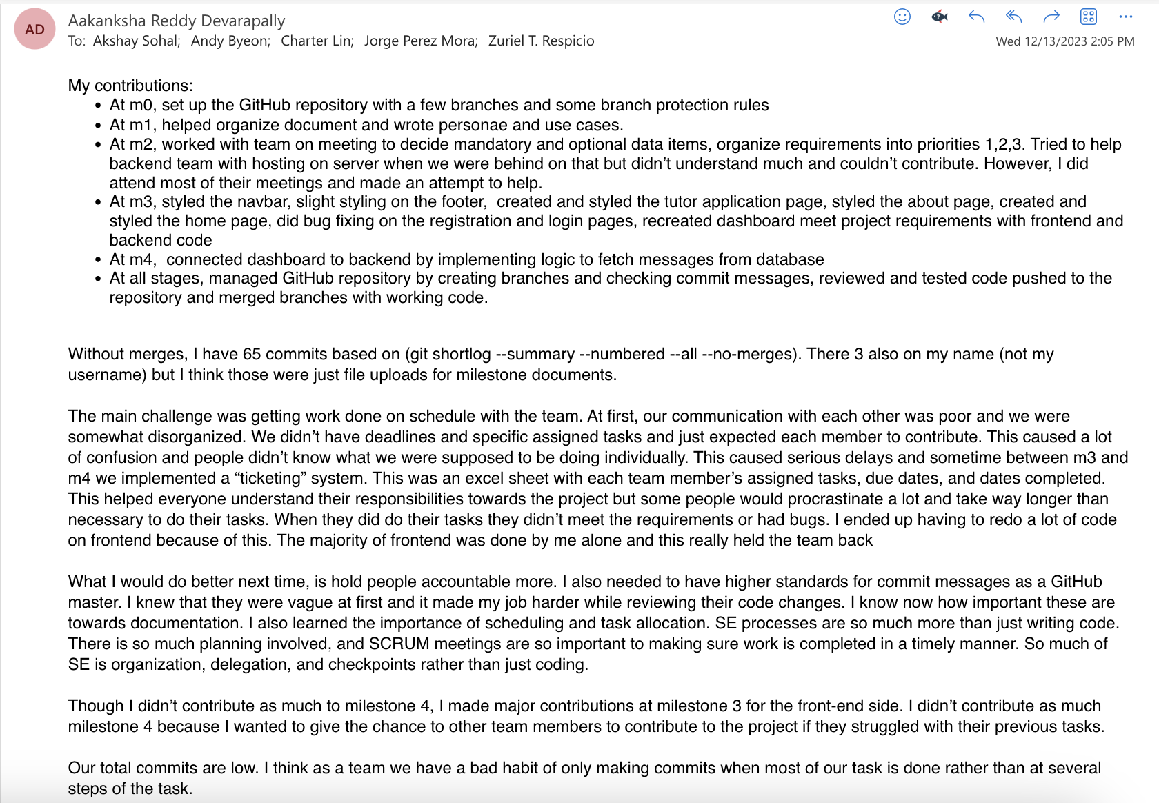

Akshat:

Jorge:

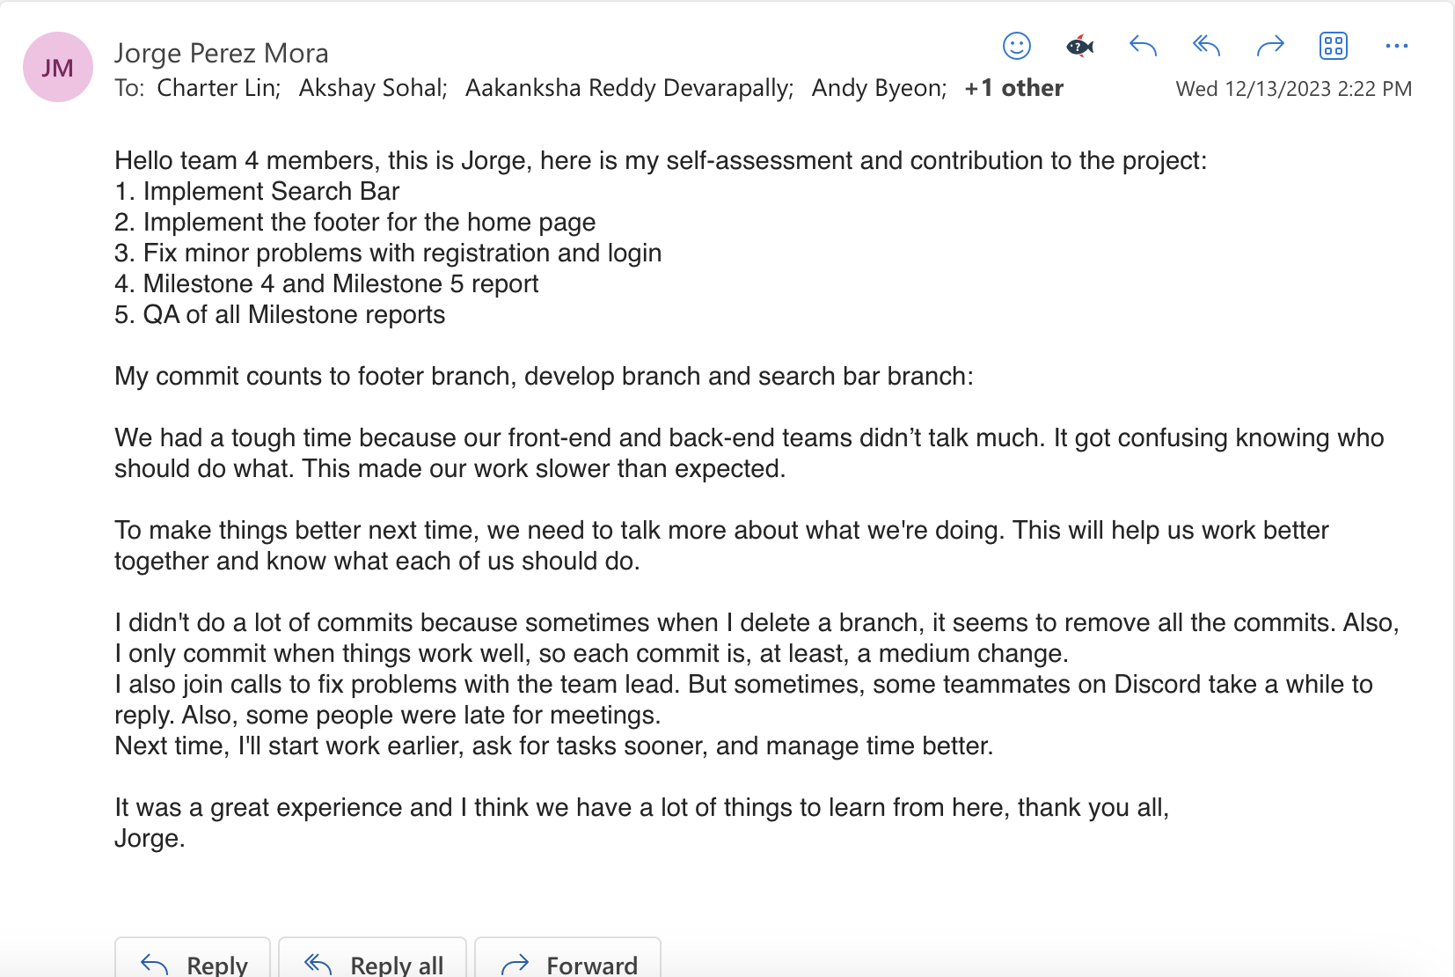

Zuriel:  
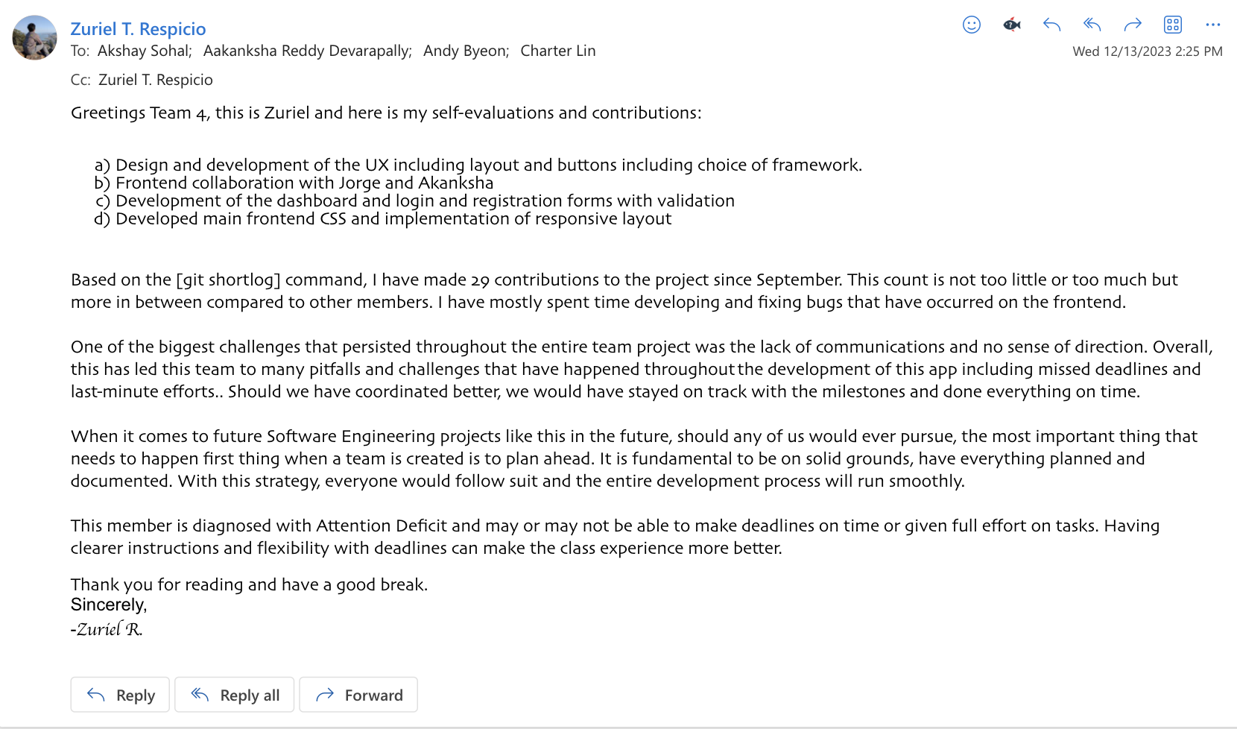

Akshat:

